**Surviving Evans O’Donnell Signal Boxes**

The L&B signal boxes at Barnstaple and Pilton were supplied by Evans O’Donnell &Co Ltd (EoD hereafter) for the opening of the line in 1898. The survival of the Barnstaple box after the closure of the railway, and its many years in use as a summerhouse/shed, is remarkable. At the time of writing, two further EoD signal boxes of similar age survive in Network Rail use, and their stories are arguably even more amazing. This short article outlines the history of all three, as well as the very small number built by EoD for other minor railways.

**Evans O’Donnell Co Ltd**

A G Evans and J P O’Donnell entered into a partnership as signalling contractors in 1894 and acquired a works next to the Great Western main line at Chippenham. The firm of Evans, O’Donnell & Co Ltd was soon attracting work from many of the main line railway companies, but relatively few of these contracts required EoD to supply the actual signal box buildings. Only approximately 40 boxes in total were supplied over a six-year period before 1903, when EoD merged with one of their competitors, Saxby and Co. Thereafter, the Chippenham factory continued to supply signal boxes, but made to Saxby designs. The factory grew to be one of the most important signal works in the UK and following various mergers and changes of ownership, it has continued to manufacture railway signalling equipment down to the present day. The current owners of the factory are Siemens Mobility, who plan to move to a new, purpose-built facility in Chippenham in 2025 and finally vacate the EoD site.

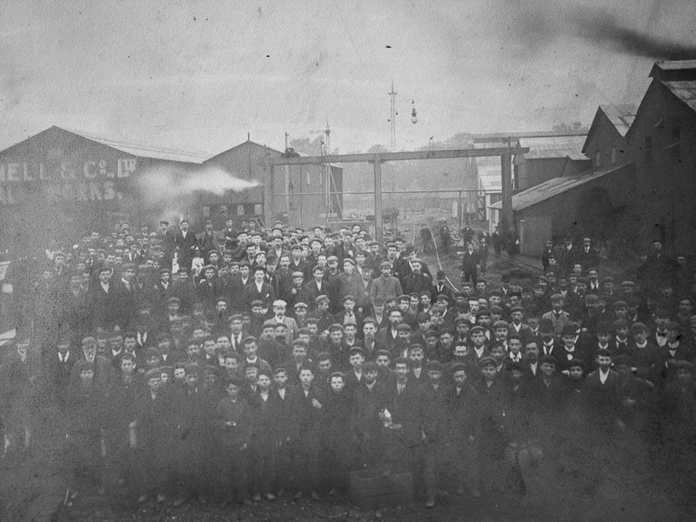

Fig 1 – The Evans O’Donnell Signal Works staff in the 1890’s, at around the time the L&B signal boxes were being made (Polunnio Ltd, <https://www.polunnio.co.uk/research-resources/photo-galleries/evans-odonnell-gallery/?show=gallery>)

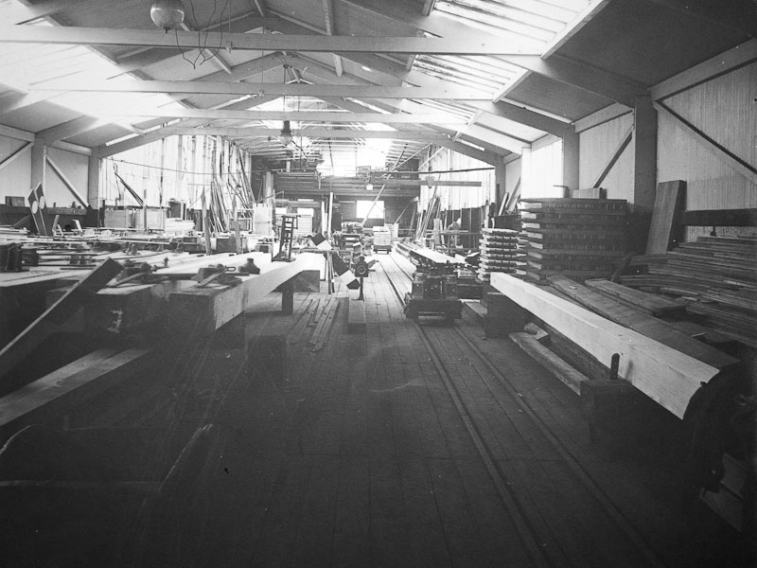

Fig 2 Evans O’Donnell carpenters’ shop in the 1890’s (Polunnio Ltd, <https://www.polunnio.co.uk/research-resources/photo-galleries/evans-odonnell-gallery/?show=gallery>)

Of the ~40 boxes supplied by EoD, all but 5 were supplied to the South Eastern and Chatham Railway (SECR). The following sections provide a potted history of the three survivors, in order of their construction date.

**Barnstaple (L&B)**

As the signalling contractor to the Lynton and Barnstaple Railway (L&B), along with lever frames, signals etc, EoD supplied two signal boxes at Pilton yard and Barnstaple Town station. The contract with EoD was approved by the board in February 1897, and although the opening of the L&B did not take place until May 1898, at the time the contract was signed, the opening was planned to be in the following January. To be completed in time for the opening therefore, it seems likely that the Barnstaple signal box would have been constructed sometime during the second half of 1897. Figs 1 and 2 are photographs of the EoD staff and their carpenters’ shop around this time. Upon closure of the L&B, the Barnstaple box formed part of Lot 4 at the auction sale, and eventually found its way to a garden on a steep hillside in Umberleigh, a small village about 9 miles to the SE. It then spent 85 years serving as a summerhouse/shed before being aquired by the L&B Trust in November 2023. It was dismantled on-site, and the parts are currently in dry storage.

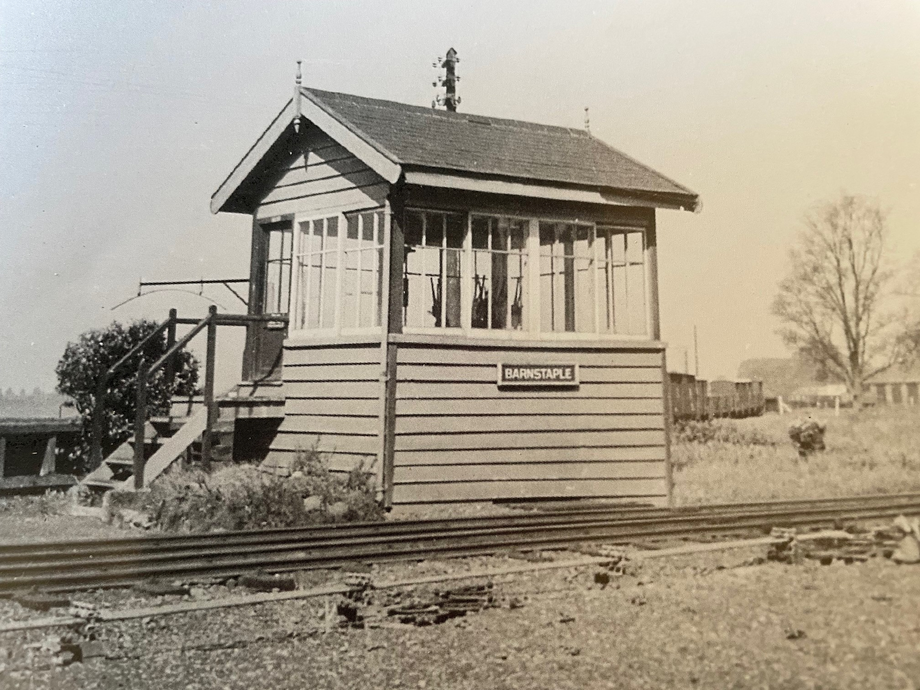

Fig 3. Barnstaple (L&B) signal box in SR days (from Catchpole – the Lynton & Barnstaple Railway 1895-1935)

The design is typical of EoD, being mainly timber weatherboarding with the characteristic EoD design of window sash, with a single horizontal glazing bar rather closer to the head than in the designs of other contemporary suppliers.

Some points of note;

* It is the one of the first, possibly *the* first (and certainly the oldest surviving) signal boxes supplied by the factory in Chippenham.
* There are windows all the way round. Although not unusual for a signal box located at a junction or multi-platform station, with busy running lines on both sides, it is difficult to understand the reason here. As well the extra cost of the windows on the rear elevation, the layout leaves no obvious location for internal fittings such as a notice board or stove.
* Despite being out of railway use for 85 years, the building frame, rafters, and some of the original internal boarding have survived, along with three of the original eleven window sashes.

It is interesting to compare the Barnstaple box with a somewhat similar box supplied by EoD a few years later to the SECR at Folkestone Harbour Pier (see Fig 4). This box was probably made in 1903, when an extension to the pier was opened and the track layout at the harbour expanded. As well as being longer than the Barnstaple box, the locking room was lit by shallow windows and is entered by a small door underneath an external landing that extends across the full width of the gable end. It is more conventional in that there is only glazing to the front half of the operating floor and a stove was provided for the signalman (even more essential here than at Barnstaple, given the exposed location on the pier).

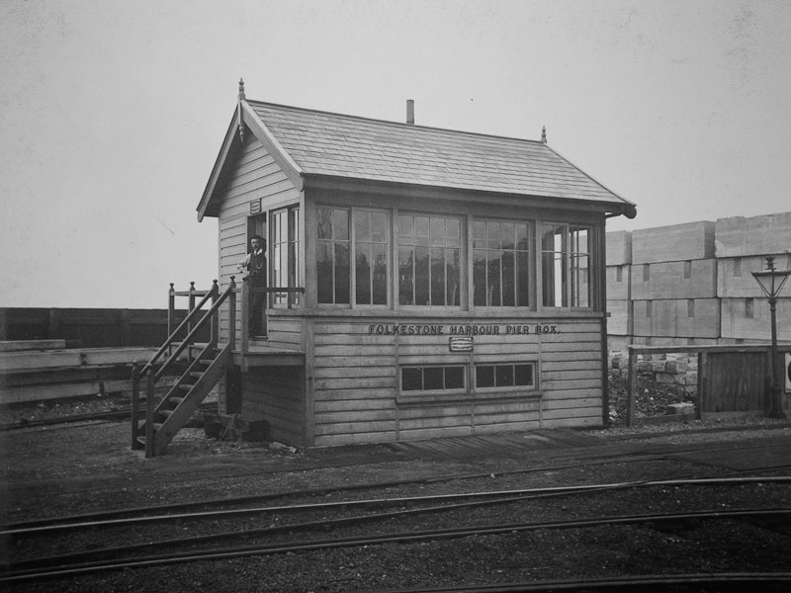

Fig 4, Folkestone Harbour Pier Signal Box (Polunnio Ltd, <https://www.polunnio.co.uk/research-resources/photo-galleries/evans-odonnell-gallery/?show=gallery>)

**Maidstone West**

Maidstone West is a large, elevated box of 115 levers that was constructed for the SECR in 1899. It is three stories high, the narrow base being of brick with the upper stories being cantilevered off the base to the front and rear. It is in near original condition, with its original frame. The only concession to modernity is the fitting of a metal external staircase. Its moment of greatest jeopardy came at exactly 11:03 on the 3rd August 1944, when it was very severely damaged by a V1 flying bomb (see <https://www.networkrail.co.uk/stories/wwii-bomb-damaged-signal-box-celebrates-120-years/> and further pictures at <https://www.kentonline.co.uk/maidstone/news/historic-signal-box-hit-by-doodlebug-celebrates-120-year-life-207868/> ). The damage to the rear of the timber structure was extensive, but rather than replace the box with one of wartime ARP (Air Raid Precautions) design, the box was repaired in exactly the original style. Not all the evidence of the bomb could be erased however, and shrapnel damage can still be seen on some of the levers. A Network Rail video on the history of the box may be found at <https://www.youtube.com/watch?v=2QQib9qeJ5I> .

In 2013, Historic England designated the box as Grade 2 listed, citing the following reasons: (copied from <https://historicengland.org.uk/listing/the-list/list-entry/1415105)>

* Rarity of type: it is one of only two *(now three!)* remaining examples of Evans O'Donnell's own design of signal box out of an original 40, and the least altered of the two *(author: now three)*
* Architectural interest: of an impressive scale of three storeys high with two full storeys overhanging on cast iron brackets and 10 bays wide, and it is the only remaining signal box retaining Evans O'Donnell's characteristic windows (*now two!*)
* Degree of alteration: intact apart from the replacement of the external staircase in steel and the roof covering
* Survival of operating equipment: it retains the original 1899 Evans O'Donnell lever frame with 115 levers and some block instruments including commutators and bells.

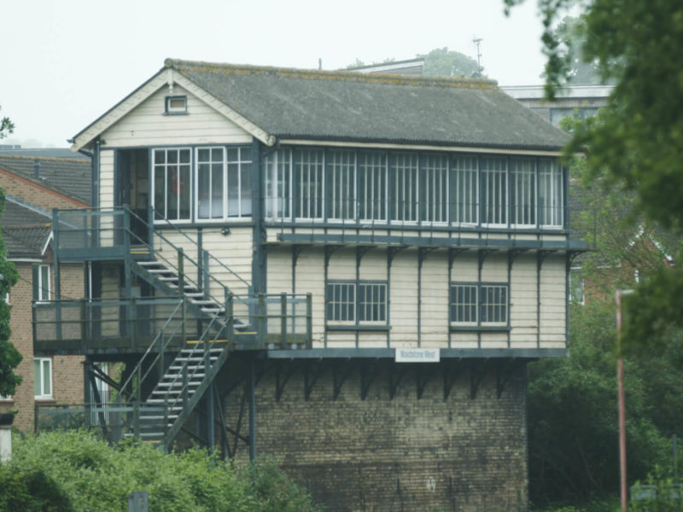

Fig 5 A recent picture of the Grade II listed Maidstone West Signal Box (Network Rail, <https://www.networkrail.co.uk/stories/wwii-bomb-damaged-signal-box-celebrates-120-years/> )

**Ryde St John’s Road**

This EoD signal box started life with the SECR in the heart of London at Waterloo Junction Station (now Waterloo East). The station opened in 1869 on the south side of Hungerford bridge where the line out of Charing Cross station was joined by a single-track connection from the LSWR Waterloo station. The box was installed c. 1900, but the station only survived as a junction until 1911, when the connecting line was closed, and the alignment converted to a footpath (a change of use that has since become more commonplace). At that time the station was renamed Waterloo East but the box continued in use until it became redundant under a 1926 Southern Railway re-signalling scheme. On the 27th June 1926 it, along with 5 other mechanical boxes in the area, was replaced by a new power box at Charing Cross (see h[ttps://www.wbsframe.mste.co.uk/public/Charing_Cross.html](https://www.wbsframe.mste.co.uk/public/Charing_Cross.html)). Amazingly, although already more than 25 years old, the Southern Railway decided to transport the EoD structure 80 miles and across the Solent, in order to install it at Ryde St Johns Road. What must have been an enormously complex logistical operation was completed on 9th Dec 1928. The EoD lever frame does not appear to have made the journey however, and a second-hand Stevens 40 lever frame was installed in the relocated box (now reduced to 30 levers). As at Maidstone East, the external wooden staircase has since been replaced by metal, and almost all the windows have also recently been replaced by modern uPVC units. <https://www.flickr.com/photos/ingythewingy/8545333463> shows the box in close to ‘as built’ condition and the picture below is a more recent view.

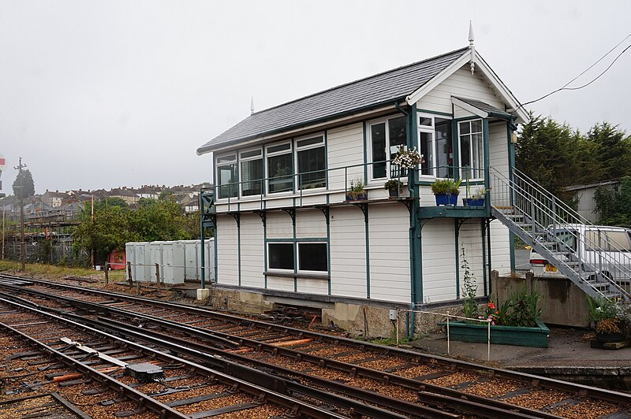

Fig 6 A recent view of Ryde St John’s Road Signal Box showing replacement windows in the locking room and the operating floor. There appears to be a single original EoD window in the porch. ( <https://www.geograph.org.uk/photo/5619240>, copyright Martin Speck and licensed under Creative Commons License)

**EoD Signal Boxes supplied to Minor Railways**

The table below lists the handfull of boxes known to have been supplied by EoD to railways other than the SECR. The L&B was their only narrow-gauge customer, and the Barnstaple box is the only known survivor from this list.

|  |  |  |  |  |  |
| --- | --- | --- | --- | --- | --- |
| Box | Railway | Date | Frame | Fate | Notes and photos |
| Pilton | Lynton and Barnstaple | 1897 | EoD 9 lever | Closed with railway in 1935 | Originally tall stone base much reduced in height c. 1918 <http://www.trainweb.org/railwest/railco/minor/lb-pilton.html> |
| Barnstaple | Lynton and Barnstaple | 1897 | EoD 9 lever | Closed and sold in 1935. See above also | <http://www.trainweb.org/railwest/railco/minor/lb-barntn.html> |
| South Harrow | Ealing and South Harrow | 1899 | EoD ~30 levers | Replaced by early power box at Rayners Lane c1953? | Archive film at; <https://www.youtube.com/watch?v=ORfyDZ9aSMc>  Details of Rayners Lane re-signalling at; <https://www.wbsframe.mste.co.uk/public/Rayners_Lane.html> |
| Easton (Isle of Portland) | Easton and Church Hope Joint | 1902 | EoD | Demolished sometime before final closure in 1962 | <https://www.flickr.com/photos/alwyn_ladell/6865631401>  <http://www.disused-stations.org.uk/e/easton/easton(jmc_c1930s)old26.jpg>  Station before the signal box was constructed?<http://www.geoffkirby.co.uk/Portland/690715/690715166LR_1.jpg> |
| Llanelly North Dock | Llanelly and Mynedd Mawr Light | Dock opened in 1903 | ? | Out of railway use before 1950 and demolished sometime after 1971 | A medium size box that controlled the railway swing bridge across the entrance to the dock and associated signals. Colourised image at;  <https://coflein.gov.uk/en/site/34207/images>  And a B/W photograph from a similar vantage point at:  <https://www.llanellich.org.uk/images/stories/LCH0071_Llanelli__Docks_a.jpg>  At some stage, the base of the box was rebuilt in brick and the upper floor clad in corrugated iron (the latter presumably post closure).  See <https://coflein.gov.uk/en/site/34721/?z=10> and <https://coflein.gov.uk/en/site/34721/images/?z=10> |

**Summary**

The Barnstaple signal box is a rare historical artefact, not just of the L&B, but also of the EoD company and the Chippenham signal works.

**Acknowledgment**

The author would like to thank Chris Osment for additional information and for improving the text.

**Bibliography**

Railway Signal Boxes: A Review. John Minnis, 2012. Published by English Heritage and available on line at <https://historicengland.org.uk/research/results/reports/6071/RailwaySignalBoxes_AReview>

The Lynton & Barnstaple Railway, G A Brown, J D C A Prideaux, H G Radcliffe, 1964. Published by David and Charles

The Lynton & Barnstaple Railway 1895-1935, L T Catchpole. Published by the Oakwood Press.

The Signal Box - a pictorial history and guide to designs. The signalling study group, 1986. Published by Oxford Publishing Company.

Westinghouse Brake & Signal in Chippenham – in photographs 1894-1981, Mark Glover, 2010. Polunnio Ltd and published on-line at <https://www.polunnio.co.uk/2018/10/06/wbs-in-chippenham-now-on-this-site/>

Malcolm Kitchen (Lynton & Barnstaple Railway Volunteer), July 2024